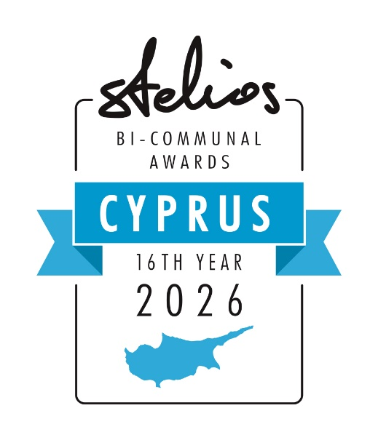
Celebrating 16 years of working for lasting peace on the island of Cyprus. The total sum awarded to Bi-Communal teams including the 2026 cash prizes is €5,300,000
APPLICATION FORM
In 2026 a total of €500,000 in cash prizes to be won by 18
Greek Cypriot and Turkish Cypriot entrepreneurs in Cyprus!

- these cash prizes are offered by the Stelios Philanthropic Foundation (www.steliosfoundation.com.cy ) a charity created by Sir Stelios Haji-Ioannou, the
creator and owner of the easy family of brands. For more information visit:
www.easy.com and www.easyhistory.info.
- From 8 January 2026 until the 30 April 2026, we are inviting applications - to be
submitted on this form - and sent by email to marios.missirlis@stelios.com. NB You will
need to complete this form by typing and send as a word document. No handwritten applications will be accepted.
- The winners will be announced by Sir Stelios Haji-Ioannou in June 2026.
- The overall GOLD winning team will receive €150,000, two SILVER winning teams will
receive €100,000 per team and six BRONZE winning teams will receive €25,000 per team
to invest in their businesses.

CRITERIA TO APPLY:

- Each team must comprise of one Greek Cypriot entrepreneur and one Turkish Cypriot
Entrepreneur, both born on the island of Cyprus that must be working in a joint
business activity on the island of Cyprus. Each business must have a minimum turnover
of 10K Euro per year and must employ one other staff member other than the owner.

DATE OF APPLICATION:
FIRST NAMES AND LAST NAMES OF THE 2 TEAM MEMBERS:

The Greek Cypriot Team Member:

Personal Details: | Mr or Ms (delete as applicable)
First name
Surname
Date of birth
Place of birth (incl. town)
LinkedIn profile of person

LinkedIn page of business
Have you applied to our awards before? | Yes / No
Have you won our awards before? | Yes, and which award and in which year? / No
 | Note the prior winners of the gold and silver awards in 2025 are precluded from winning again
Education:
Secondary (name of school)
University (name of school and degree)
Employment:
Previous employer(s)
Name of current business and website
Brief description of the activities of your current business
Address of current business
E-mail address
Mobile telephone number (incl. country code)
The Turkish Cypriot Team Member:
Personal Details | Mr or Ms (delete as applicable)
First name
Surname
Date of birth
Place of birth (incl. town)
LinkedIn profile of person
LinkedIn page of business
Have you applied to our awards before? | Yes / No
Have you won our awards before? | Yes, and which award and in which year? / No  Note the prior winners of the gold and silver awards in 2025 are precluded from winning again
Education:
Secondary (name of school)
University (name of school and degree)
Employment:
Previous employer(s)
Name of current business and website
Brief description of the activities of your current business
Address of current business
E-mail address
Mobile telephone number (incl. country code)

The Bi-Communal Business Cooperation:
Year on which the above business partners first met
Location of initial meeting
Number of meetings between the 2 team members in 2025 (including zoom/ teams meetings)
Trading Activity:
Trading name of your joint business activity
Joint business trading activity
2025 total sales in euro of joint business activity, if any
2026 projected sales in euro of joint business activity
2025 approx. % of sales to Greek Cypriot market
2025 approx. % of sales to Turkish Cypriot market
Details:
Business website
Number of employees
Number of customers
Is your business currently cash-flow positive?

WHY SHOULD YOUR TEAM RECEIVE THIS AWARD? (no more than 50 words):

¨¨¨¨¨¨¨¨¨¨¨¨¨¨¨¨¨¨¨¨¨¨¨¨¨¨¨¨¨¨¨¨¨¨¨¨¨¨¨¨¨¨¨¨¨¨¨¨¨¨¨¨¨¨¨¨¨¨¨¨¨¨¨¨
HOW WILL YOUR JOINT BUSINESS USE THE AWARD MONEY?

…………………………………………………………………………………………………….

Bank details of the company / physical persons for the payment. We will not consider applications without a valid completed IBAN
Greek Cypriot team member
Account holder ______________________________________________Bank
name__________________________________________
IBAN_____________________________________________________________________________________________________________
BIC/SWIFT________________________________________________________________________________________________________

Turkish Cypriot team member
Account holder ______________________________________________Bank
name__________________________________________
IBAN_____________________________________________________________________________________________________________
BIC/SWIFT________________________________________________________________________________________________________

In Case of a Joint Account in the name of a company
Account holder ______________________________________________Bank
name__________________________________________
IBAN_____________________________________________________________________________________________________________
BIC/SWIFT________________________________________________________________________________________________________
By applying for these awards, we agree to:
- Allow the Stelios Foundation to process my data on the application form and publish the fact that you have applied and or won.
- Follow the LinkedIn page of the Stelios Philanthropic Foundation in Cyprus https://www.linkedin.com/showcase/stelios-foundation-headquarters-nicosia/?viewAsMember=true
- LinkedIn QR Code: 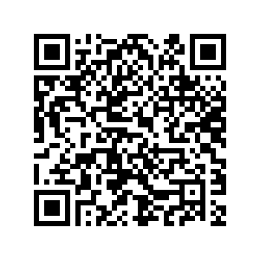
- Connect on LinkedIn with www.linkedin.com/in/marios-missirlis-b4763a334/
- If you win an award, you should promote the current and future awards on LinkedIn after the ceremony and include award details as a permanent logo on your business website homepage (in the footer) with a clickable link to the www.steliosfoundation.com.cy
- Without affecting your ability to win these awards , we are asking you if you are willing to discuss the possibility of your business joining the easy family of brands ( see the 3 minute video on www.easyHistory.info yes ___ no _____, if yes which easy brand would you like to use ? easy_____________

I understand that all judging decisions in these awards are made by Sir Stelios and are final. I certify that the facts above are correct. I understand that the Stelios Philanthropic Foundation will process any data that I have provided on this form and in any attachments for the promotion of the Awards.
Please fill in your details below confirming your application as stated above and email the word file to marios.missirlis@stelios.com not later than 30 April 2026.

Name of
applicants
Name of
Company
Date

