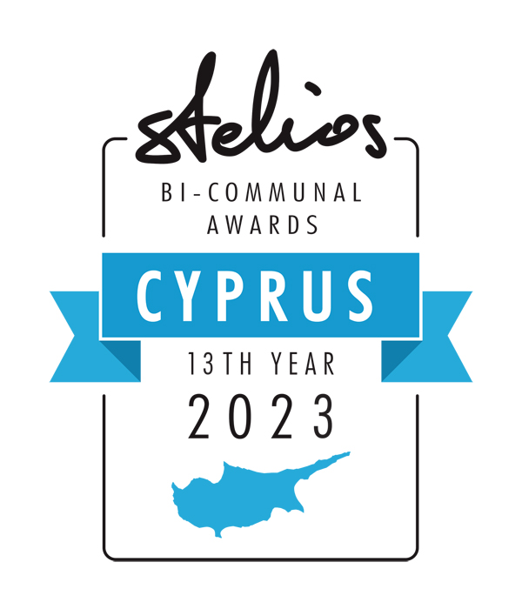

Stelios Bi-Communal Awards 2023
13th year
200,000 euro to be won by 20 Greek and Turkish Cypriot entrepreneurs
For more details and to download this application visit www.steliosfoundation.com.cy
The date of this form is Draft as at 21 November 2022 deadline to submit applications not later than Friday 27th of January 23 . The winners will be announced during a zoom ceremony in early March 2023.
Please complete the application form in word format and e-mail it as an attachment to: marios.missirlis@stelios.com
Total sums awarded to bi-communal teams over the last 13 years including this year is 4,190,000 euro.
DATE OF APPLICATION:
NAMES OF THE 2 TEAM MEMBERS:

The Greek-Cypriot Team Member:

Personal Details: | Mr or Ms (delete as applicable)
First name
Surname
Date of birth
Place of birth (incl. town)
Facebook page
Have you applied to our awards before ? | Yes / No
Have you won our awards before ? | Yes and which year ? / No
Education:
Secondary (name of school)
University (name of school and degree)
Employment:
Previous employer(s)
Name of current business
Brief description of the activities of your current business
Address of current business
E-mail address
Mobile telephone number (incl. country code)
The Turkish-Cypriot Team Member:
Personal Details | Mr or Ms (delete as applicable)
First name
Surname
Date of birth
Place of birth (incl. town)
Facebook page
Zoom id
Your current home address
Have you applied to our awards before ? | Yes / No
Have you won our awards before ? | Yes and which year ? / No
Education:
Secondary (name of school)
University (name of school and degree)
Employment:
Previous employer(s)
Name of current business
Brief description of the activities of your current business
Address of current business
E-mail address
Mobile telephone number (incl. country code)

The Bi-Communal Business Cooperation:
Year on which the above business partners first met
Location of initial meeting
Number of meetings between the 2 team members in 2022 (including zoom/ teams meetings)
Trading Activity:
Trading name of your joint business activity
Joint business trading activity
2022 total sales (EU) of joint business activity, if any
2023 projected sales (EU) of joint business activity
2022 approx. % of sales to Greek-Cypriot market
2022 approx. % of sales to Turkish-Cypriot market
Details:
Business website
Number of employees
Number of customers
Is your business currently cash-flow positive?

WHY SHOULD YOUR TEAM RECEIVE THIS AWARD? (no more than 50 words):

¨¨¨¨¨¨¨¨¨¨¨¨¨¨¨¨¨¨¨¨¨¨¨¨¨¨¨¨¨¨¨¨¨¨¨¨¨¨¨¨¨¨¨¨¨¨¨¨¨¨¨¨¨¨¨¨¨¨¨¨¨¨¨¨
HOW WILL YOUR BUSINESS USE 20,000EU?

